Design and planning for Application that serve index-based insurance contracts and Chatbot for farmers

|  |  |
| --- | --- |
| Rahul Solanki | 2017140058 |
| Sagar Waghela | 2017140064 |
| Jaydeep Vaghasiya | 2017140061 |

1. **Use Case Diagram**

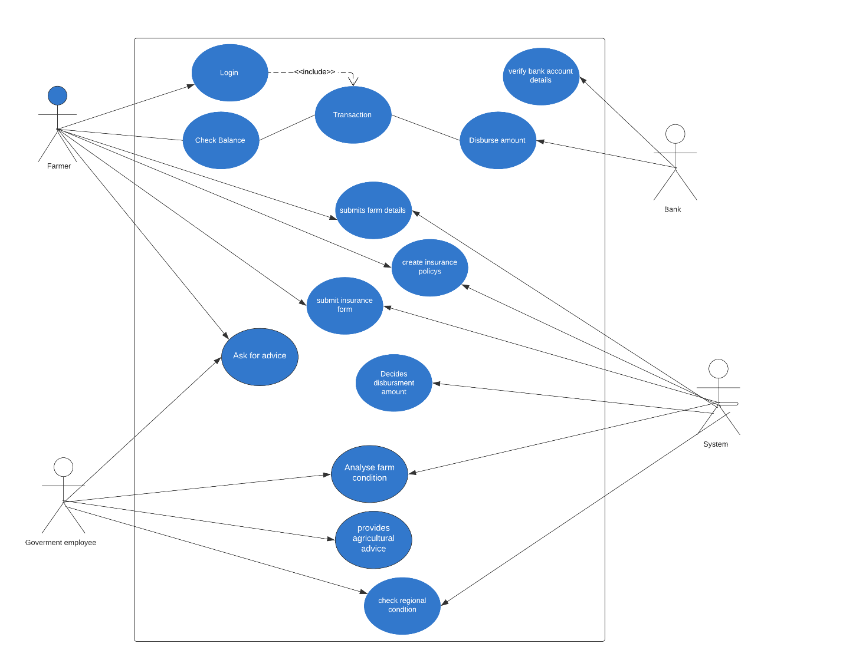

Link:

https://www.lucidchart.com/invitations/accept/e14982ff-69af-4cd4-a8ad-f1d46f54f026

1. **Class Diagram**

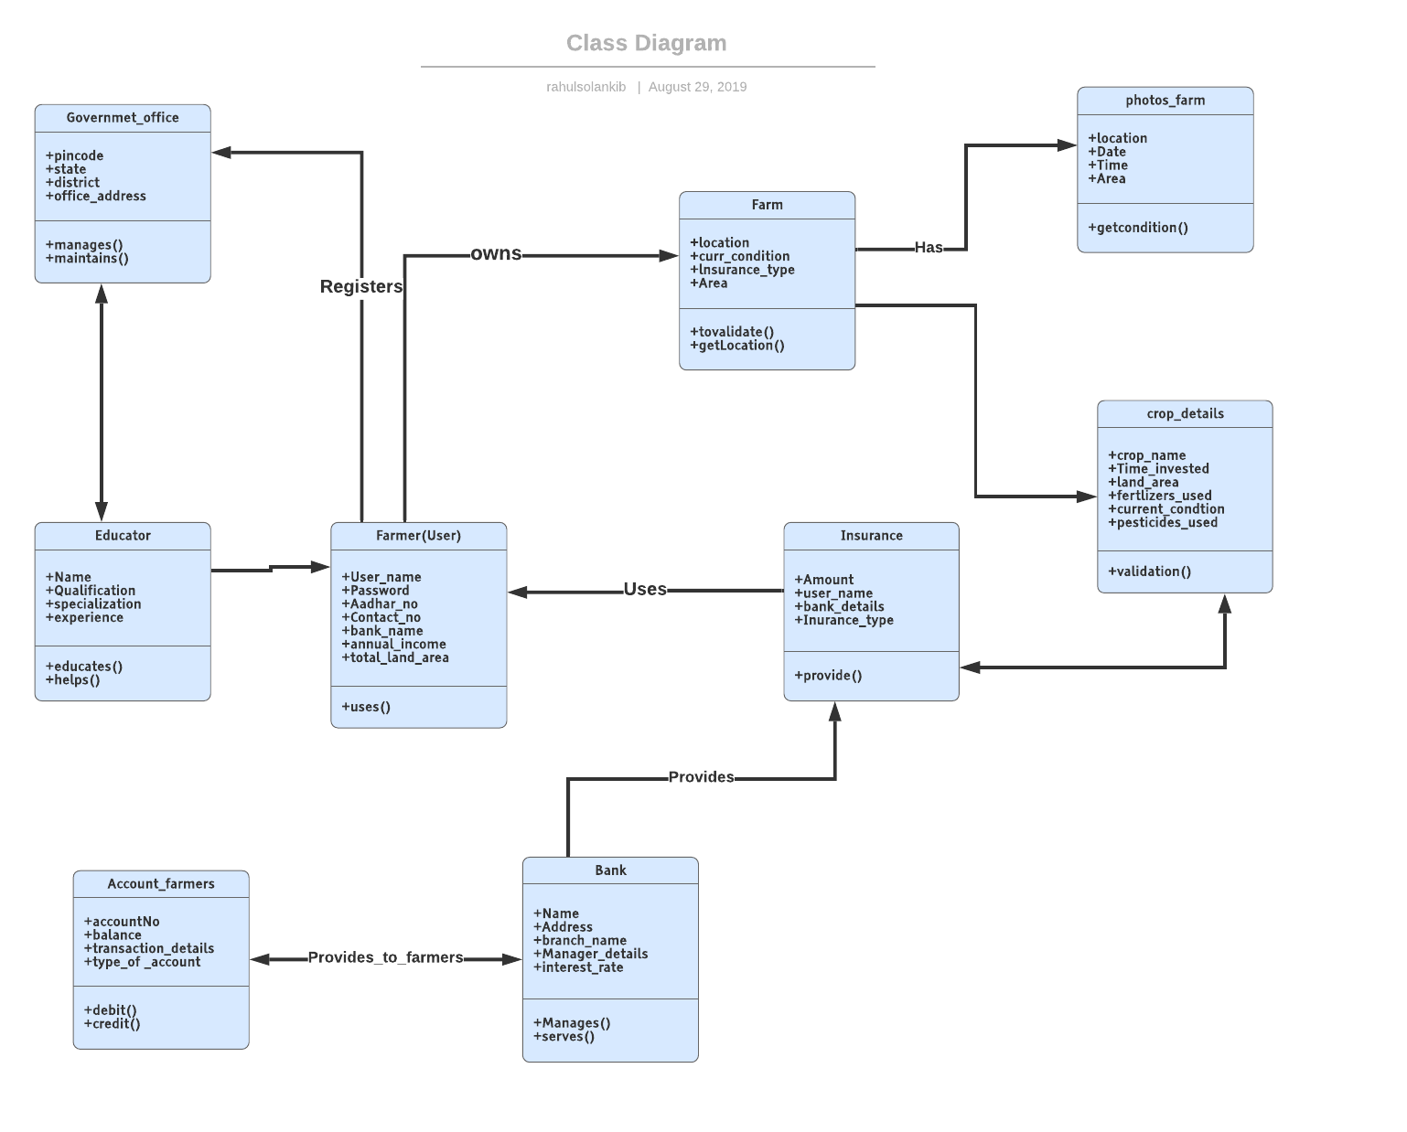

Link:

https://www.lucidchart.com/invitations/accept/5b62b96f-8fb0-4c49-9380-9d70e242d998

1. **Activity Diagram**

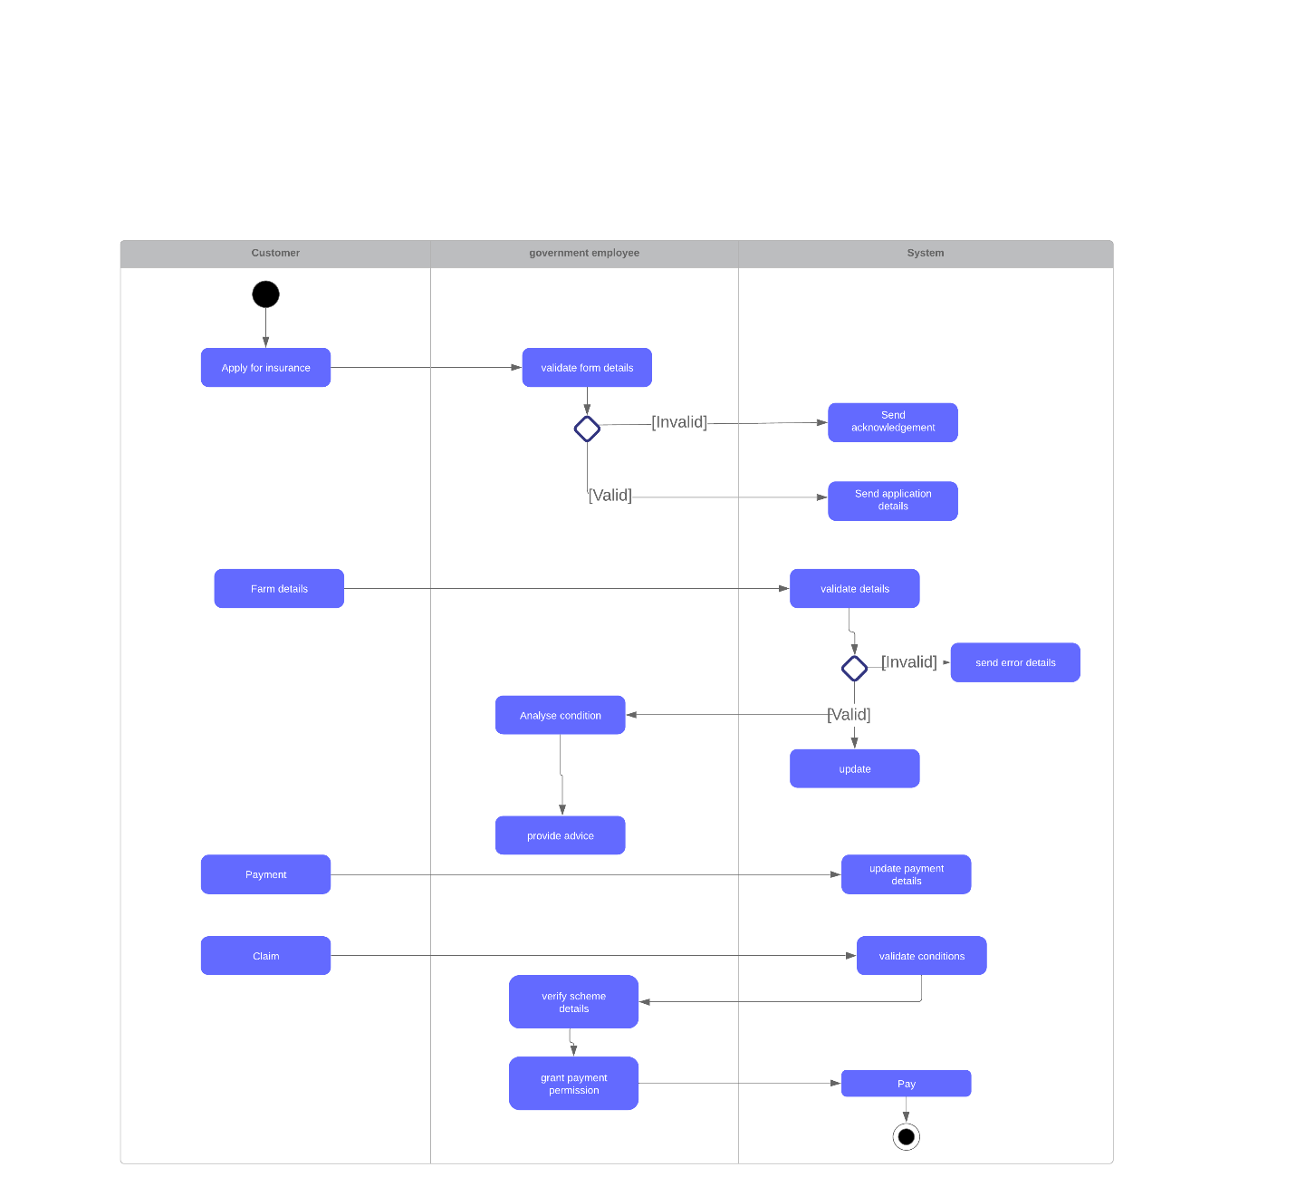

Link:

https://www.lucidchart.com/invitations/accept/74301576-6513-4e0d-ae6f-fbc96463aba2

1. **Sequence Diagram**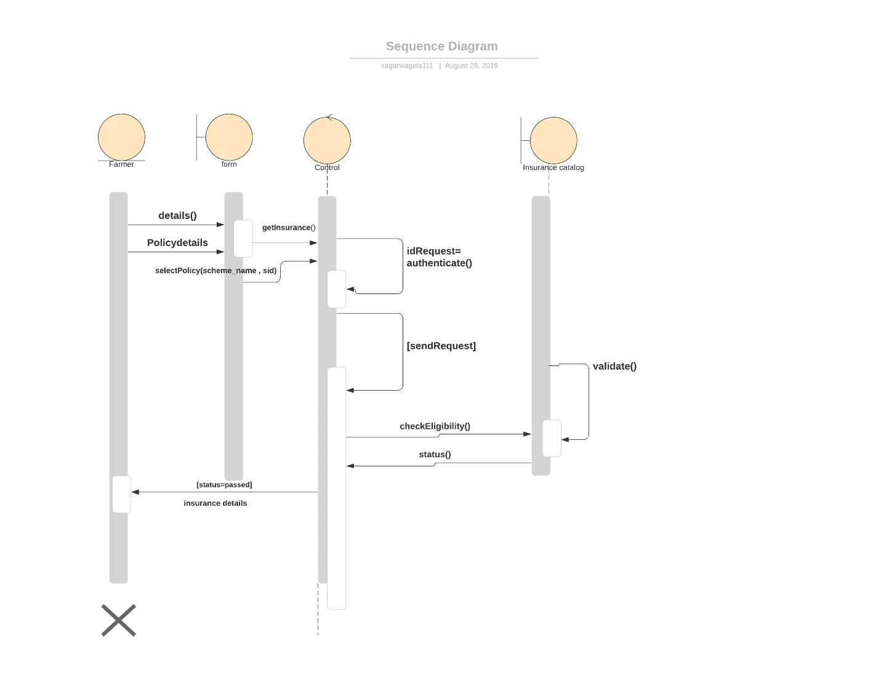

Link:

https://www.lucidchart.com/invitations/accept/22fc2dc0-9bd5-4b8b-9a03-035ecaba1563

1. **State Diagram**

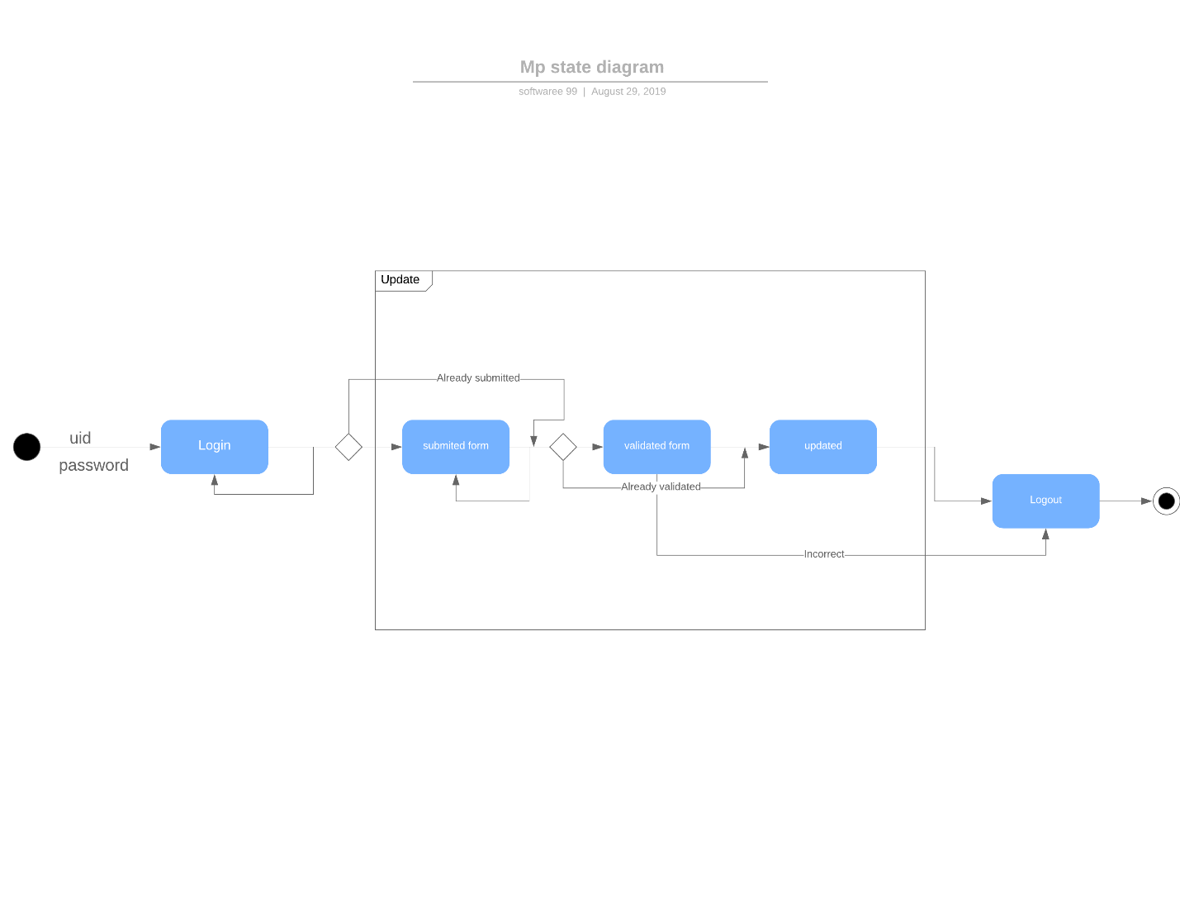

Link:

https://www.lucidchart.com/invitations/accept/6d6227ba-abeb-4ca6-a955-167d979baf2a

1. **Data Flow Diagram**

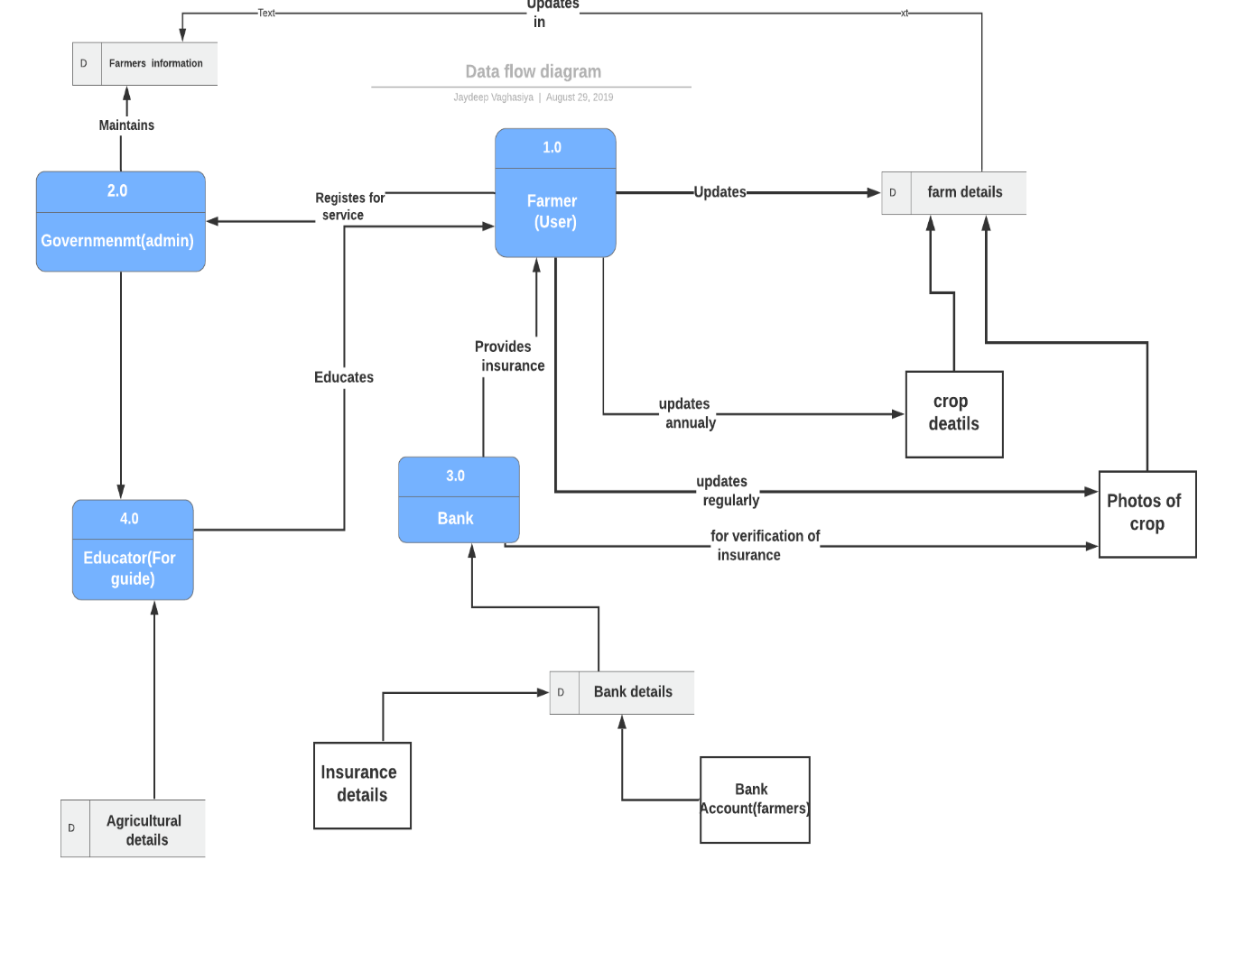

Link:

<https://www.lucidchart.com/invitations/accept/56840088-30e1-4ef3-b45c-5590ba08f4fa>

1. **Gantt Chart:**